15/4/2018

Monty Panday

215299028

Tic Tac Toe

Assignment 1

Tic Tac Toe

Assignment 1

# Introduction

This report will outline the core features of my Tic Tac Toe game. The game implements all of the core features and a few extensions. Please find the attached snapshots and code snippets. The source code is well documented. The app uses Auto-layout and will scale well in most of the latest screens. Please reduce the volume if you find the background music is too loud.

# Start the game

When you start the game, the first screen will show three buttons and a volume control. The game will start playing background music.

# 

## Single Player - Player vs Computer logic

Press the single player button if you want to play with the computer. On the next screen, you can specify a name for yourself and choose either one of cross or zero as your icon. The screen will look like below.

Please note that you cannot change the name of player 2 in this case because computer likes the name AI. But, you can choose an icon. Click on the icon adjacent to your name to switch it.

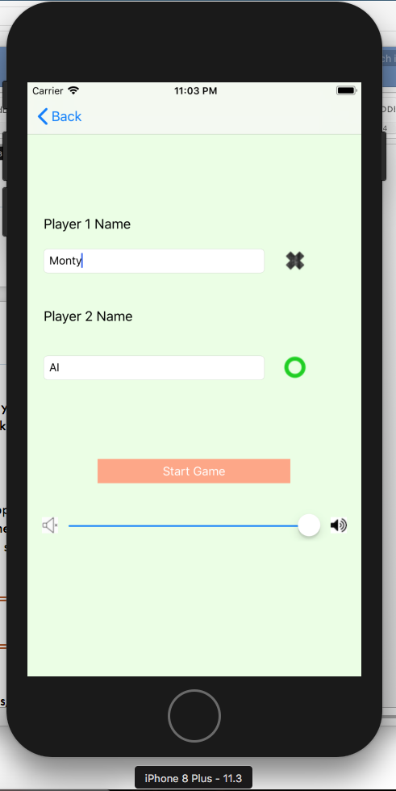

### Start the game

Click on Start Game button. You will see the grid and can start playing. You will see the score based on how many games this particular user(you) have won or lost against the AI. Note that each game is archived. We will talk about it later in extensions. In this case, I won 4 games and AI had won only one.

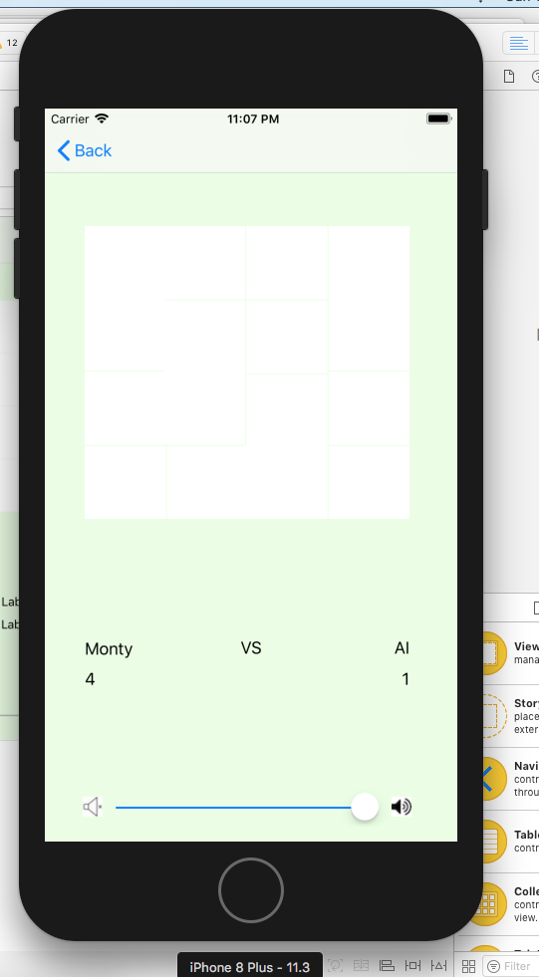

When you click on any button, the AI knows that it is its turn. It will play its turn but only if you have not won the game with your move. The game will be automatically archived, and the red message appears showing the winner’s name. Press the restart button and start another game.

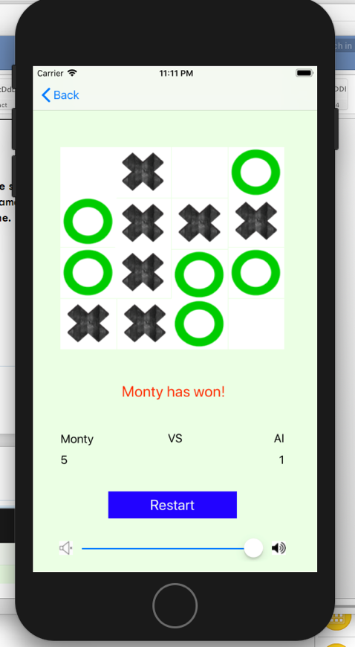

## Player vs Player logic

Press the multi-player button and two players can play the game. In this case, the name of player 2 can be changed according to your wish. Please note that I have selected zero icon for the first player this time. Press Start Game button to start the game.

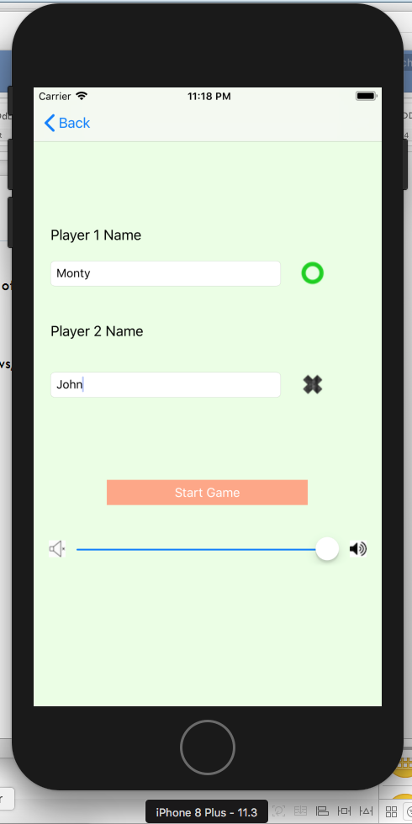

Please note that this time, when you click the button, the app waits for the second user to click now. In this previous case it was AI. In this case, it will be the person playing with you. The rest is the same. The game will be archived, and you can see it in History.

This is the function called when a user clicks a button. In multiplayer mode, it is called once given the UIButton which was pressed. In single player mode, it is also called second time but with a random button which was not earlier clicked. The tag of the button is then appended to an array so that I can use it to find unclicked buttons. Appropriate image is set based on what icon the user had chosen for himself. Game is updated means the two-dimensional arrays in the game which are used for calculations are updated. Then, we determine whether to stop the game if the current user has won. If yes, no further clicks do anything because the game is finished. User can now choose to start a new game.

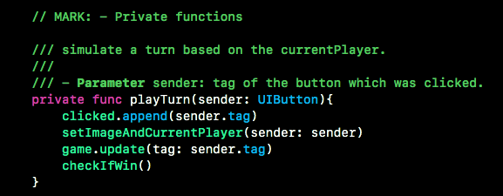

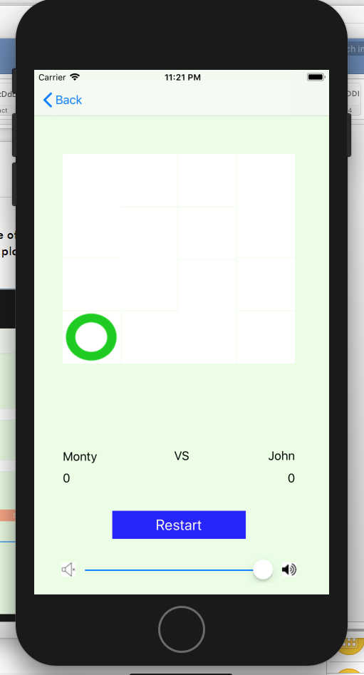

## Core User Stories:

1. As a player, I want to be able to choose the mode of the game: Single player or two players.

You can use to using Single Player and Multi Player buttons. Please refer to screenshots above.

1. As a player, I want to be able to choose my symbol: [X] or [O].

You can choose a symbol for your yourself when you specify your name. Please refer to screenshots above.

1. As a player, I want to see my score – how many times I won vs the other player.

I have implemented it in keeping in mind that the two players might have played previously. So, if the same two players have played before, assuming that either of them has won few games, there count will not start from zero. Although, for two new players or two players which are playing together for the first time, there score will start from 0-0.

1. As a player, I want to be able to start/restart the game, at any point.

You can restart the game at any point using the Restart Button.

1. As a player, I want to see a message when the game is over.

You can see a red color message when a player won the game.

## Other Features

### Choose symbol

You can choose the symbol for yourself when you specify your name, before starting the game. Please find the attached screenshot above. Each player object have an icon which is used to set the right image when this player clicks the button.

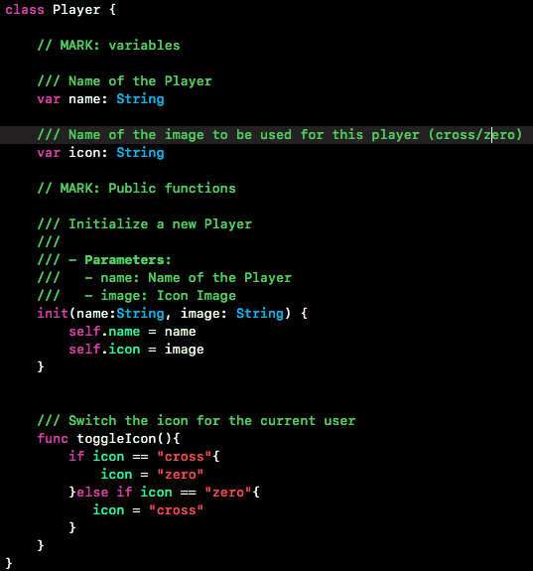

# Extensions

## Hear Music

As soon as the game load, it will start playing background music. The music is a mp3 file which is played again and again. You can use volume control to change the volume.

Import AVFoundation to use AVAudioPlayer. UISlider is used to change volume. Please note that when you jump from one view to another, the volume still remains the same it was before on the previous page and vice versa. This is because on segue it copies the AVAudioPlayer current state.

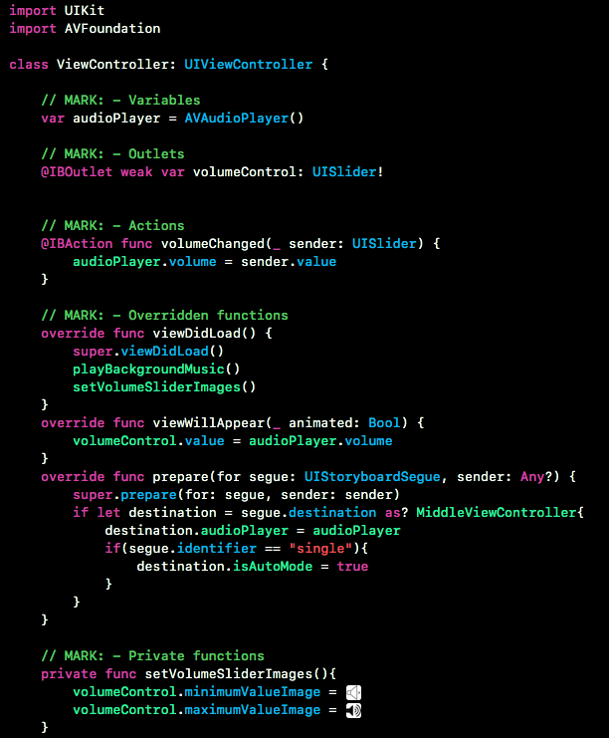

And finally, the magic which plays music.

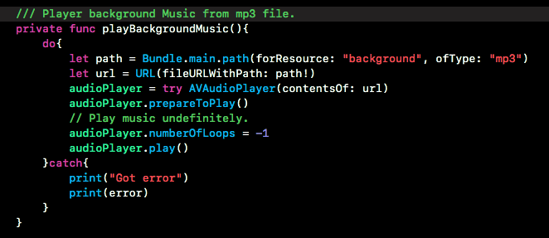

## History of games

Click on the History button to see the history of all previous games in a UITableView. Please note that only those games are stored which were won by either of the players i.e. TIE’s are not stored. The winner’s name is green whereas the red denotes the person who lost the game.

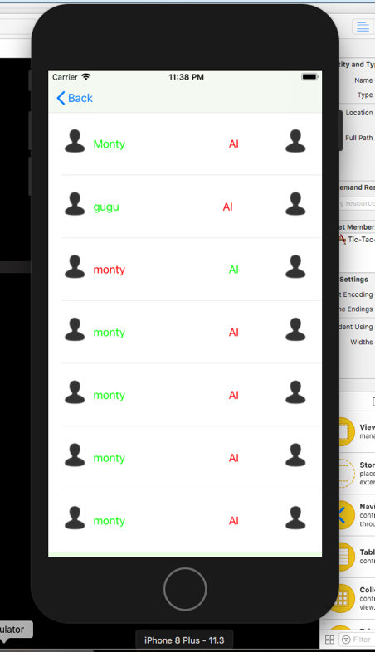

Objects can be archived using NSCoding. The class must implement encode method and a convenience init like below.

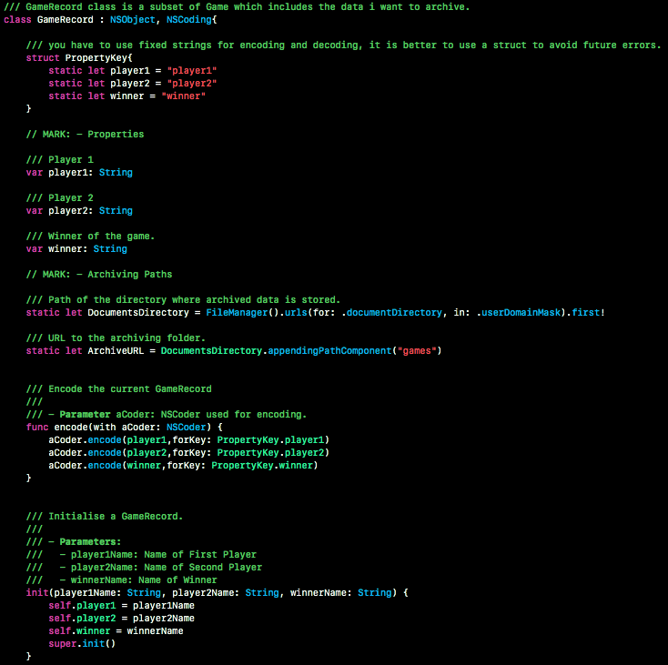

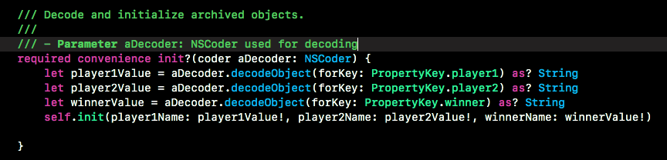

Please note that only this will not archive and unarchive data. These are the methods which are internally called to do that. But, you have to do a little more before you can save objects. You need to save the game like below:

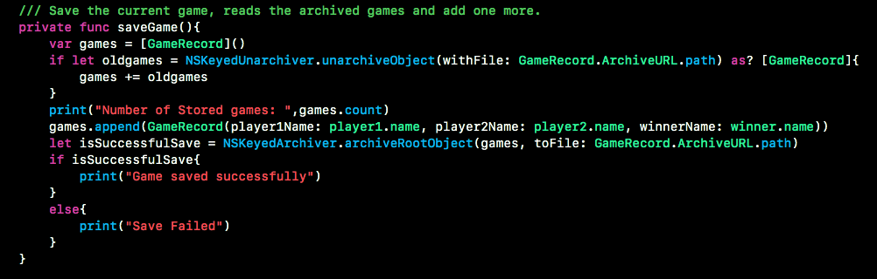

And retrieve the games like below:

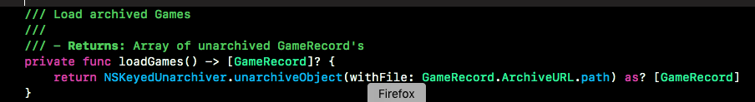

In case, there is no history available, it will display a message like below.

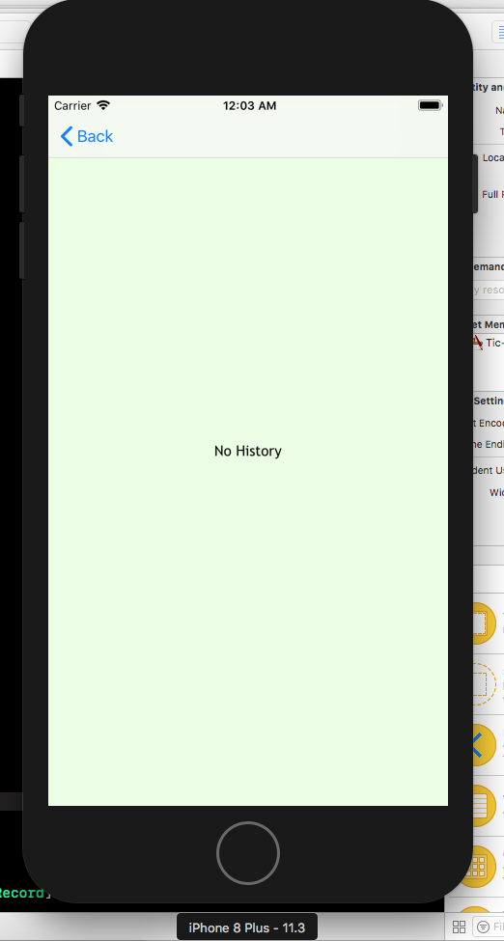

## Auto- Layout

Auto-layouts is being actively used to make the user interface fit in to all different screens. It loads well in all different screens. Please find the attached snapshot below showing the game running in an iPad.

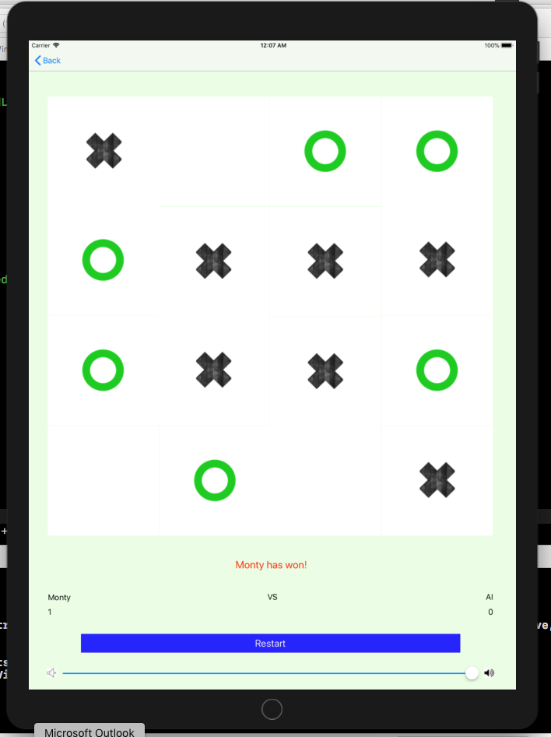

Thanks for your patience, I hope you will like my work.